**DATA HANDLING USING ‘Pandas’ and DATA VISUALIZATION USING ‘Seaborn’**

**Using the pandas function read_csv(), read the given ‘iris’ data set.**

1. Use appropriate functions in pandas to display
2. Shape of the data set
3. First 5 and last five rows of data set(head and tail)
4. Size of dataset
5. No:of samples available for each variety
6. Description of the data set( use describe

**Program**

import numpy as np

import matplotlib.pyplot as plt

import seaborn as sns

import pandas as pd

col=['sepal_length','sepal_width','petal_length','petal_width','type']

iris=pd.read_csv("iris.csv",names=col)

print("shape:",iris.shape)

print("*********")

print("First five rows")

print(iris.head())

print("*********")

print("Last five rows")

print(iris.tail())

print("Size:",iris.size)

print("*********")

print("no of samples available for each type")

print(iris["type"].value_counts())

print("*********")

print(iris.describe())

**Output**

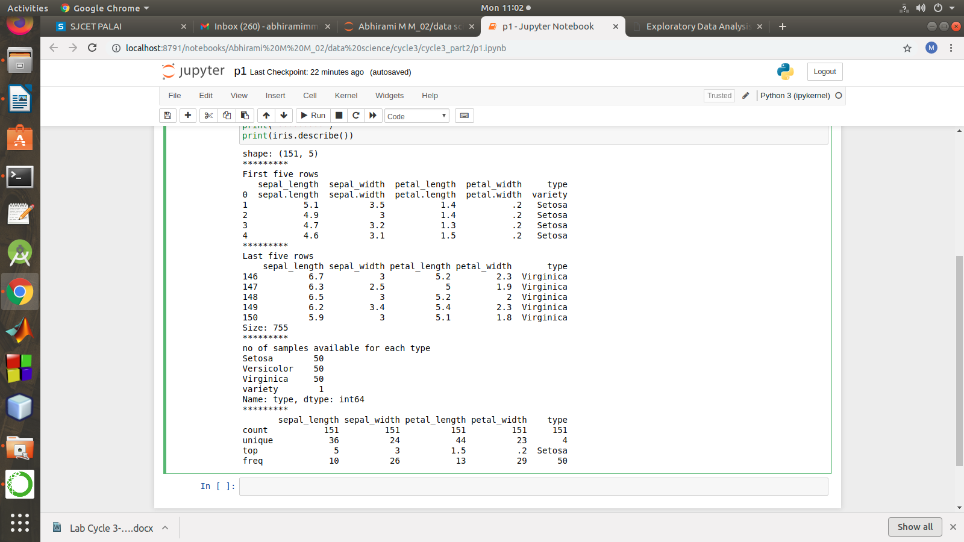

1. Use pairplot() function to display pairwise relationships between attributes. Try different kind of plots {***‘scatter’, ‘kde’, ‘hist’, ‘reg’}*** and different kind of markers

#### Program

import numpy as np

import pandas as pd

import seaborn as sns

import matplotlib.pyplot as plt

%matplotlib inline

df = pd.read_csv("iris.csv")

**g = sns.pairplot(df)**

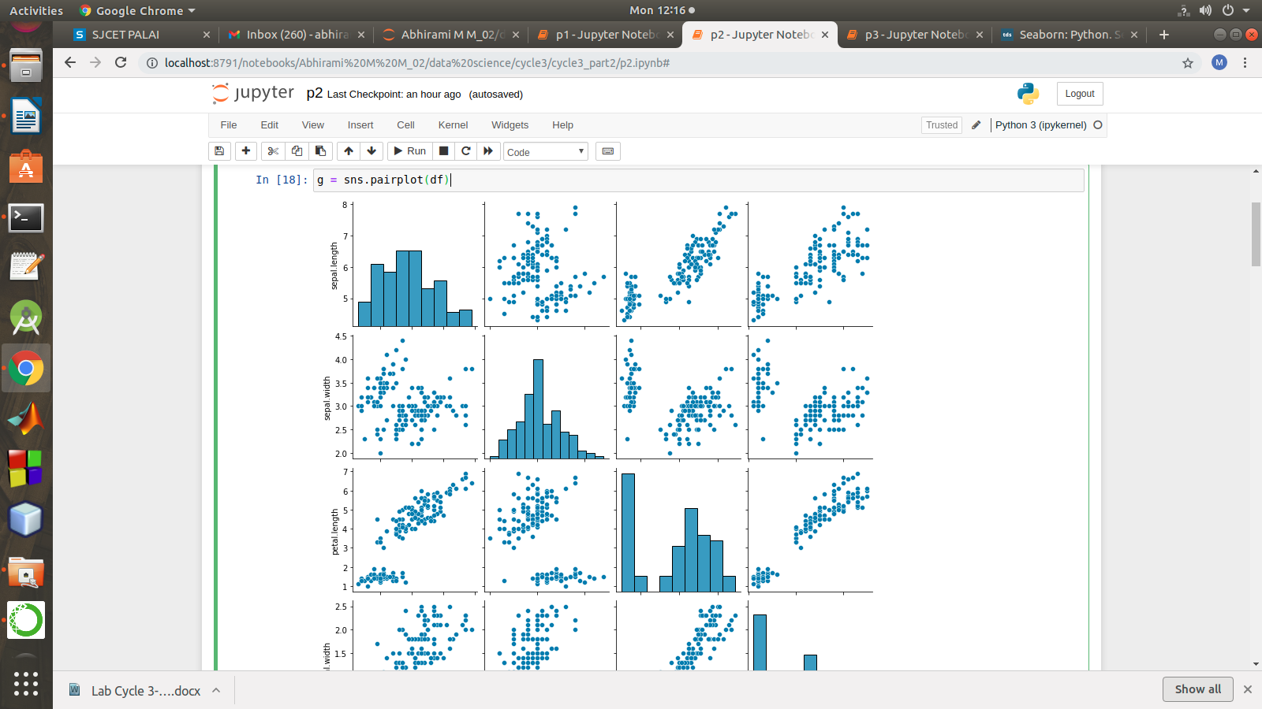

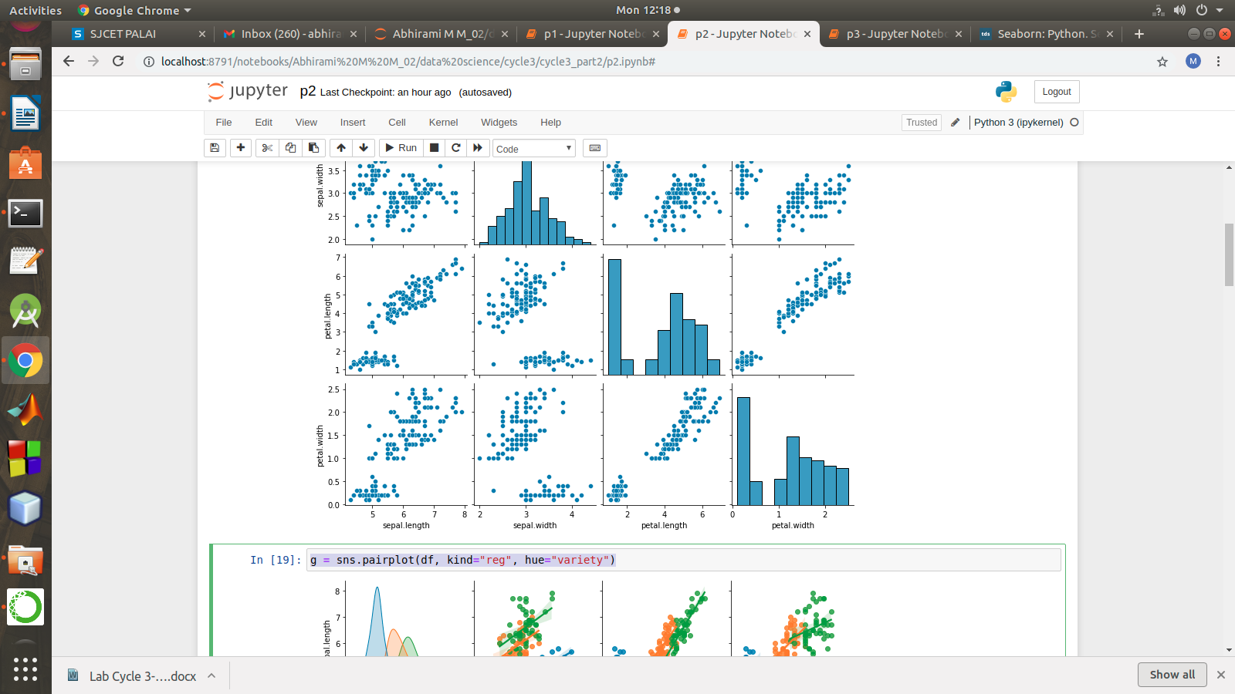

**g = sns.pairplot(df, kind="reg", hue="variety")**

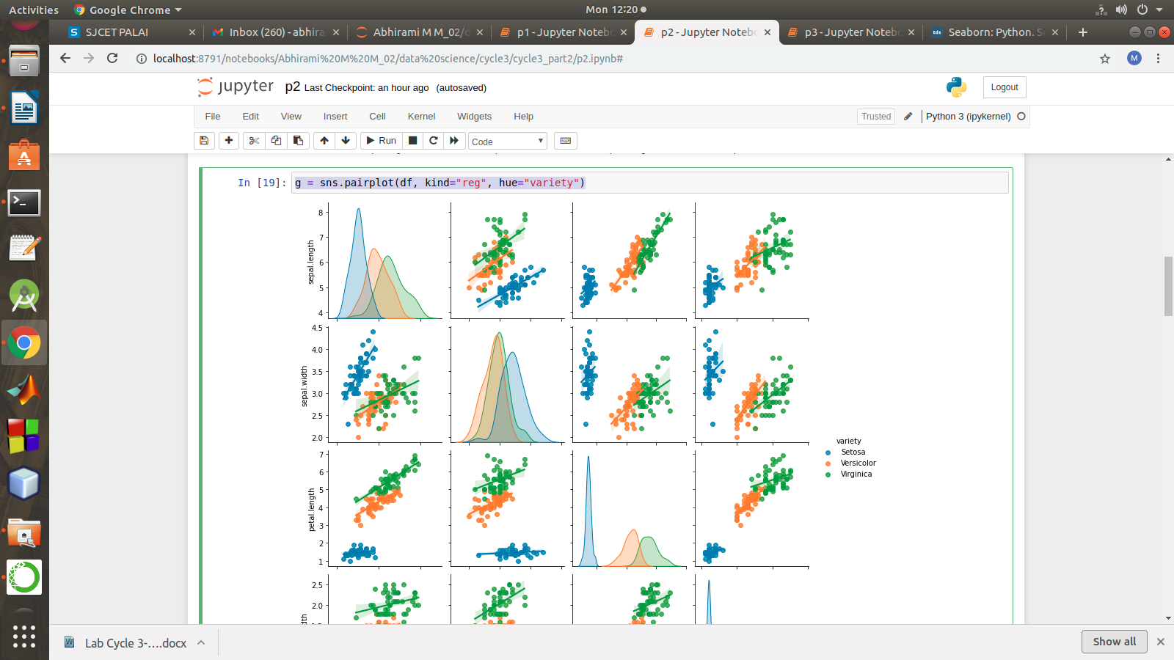

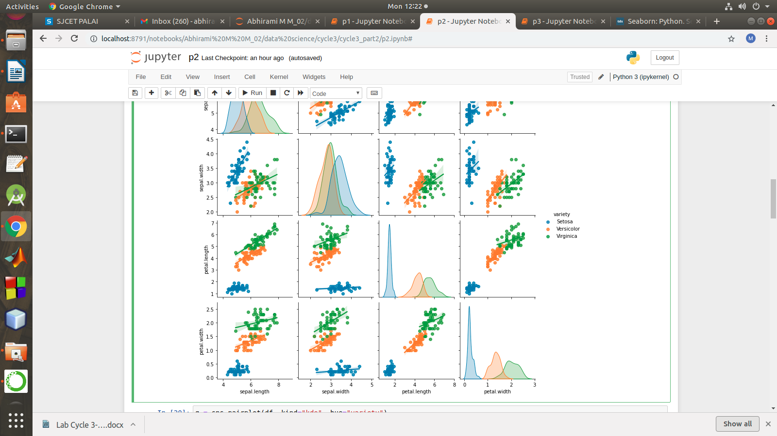

**g = sns.pairplot(df, kind="kde", hue="variety")**

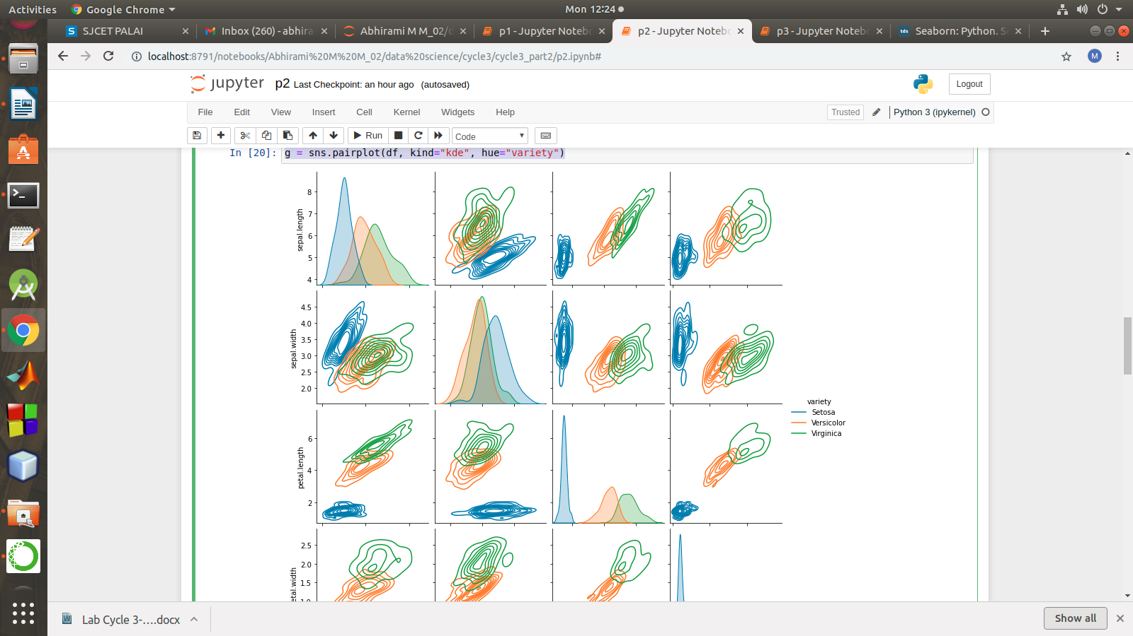

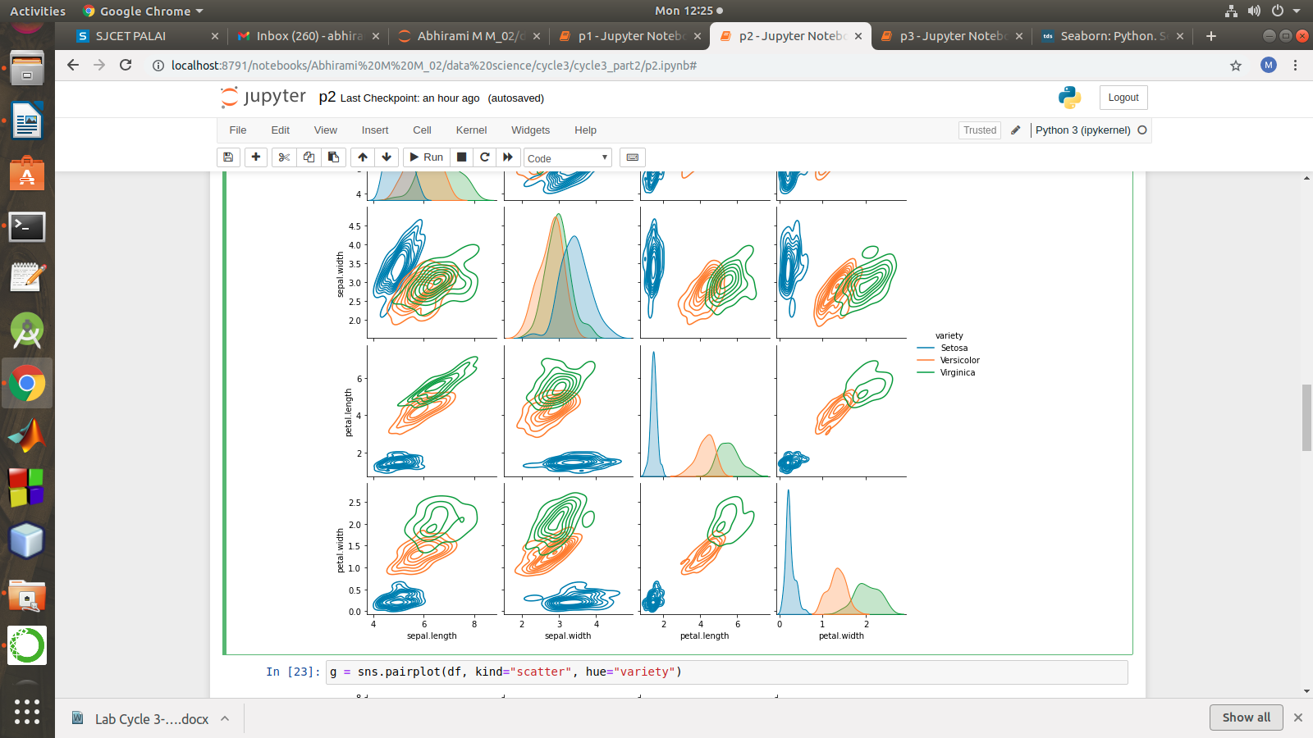

**g = sns.pairplot(df, kind="scatter", hue="variety")**

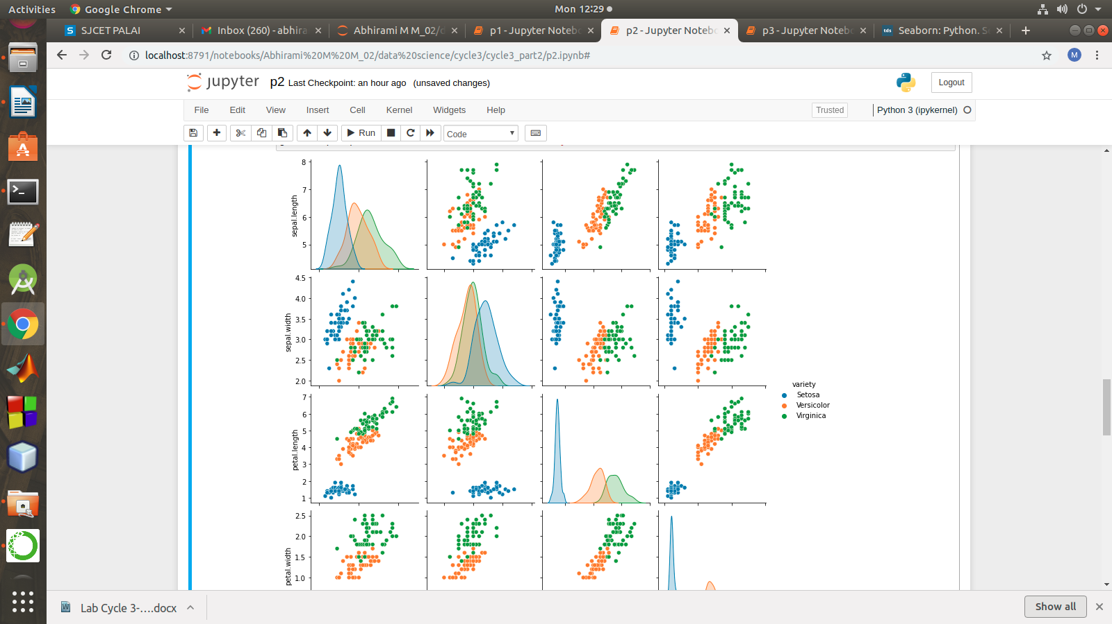

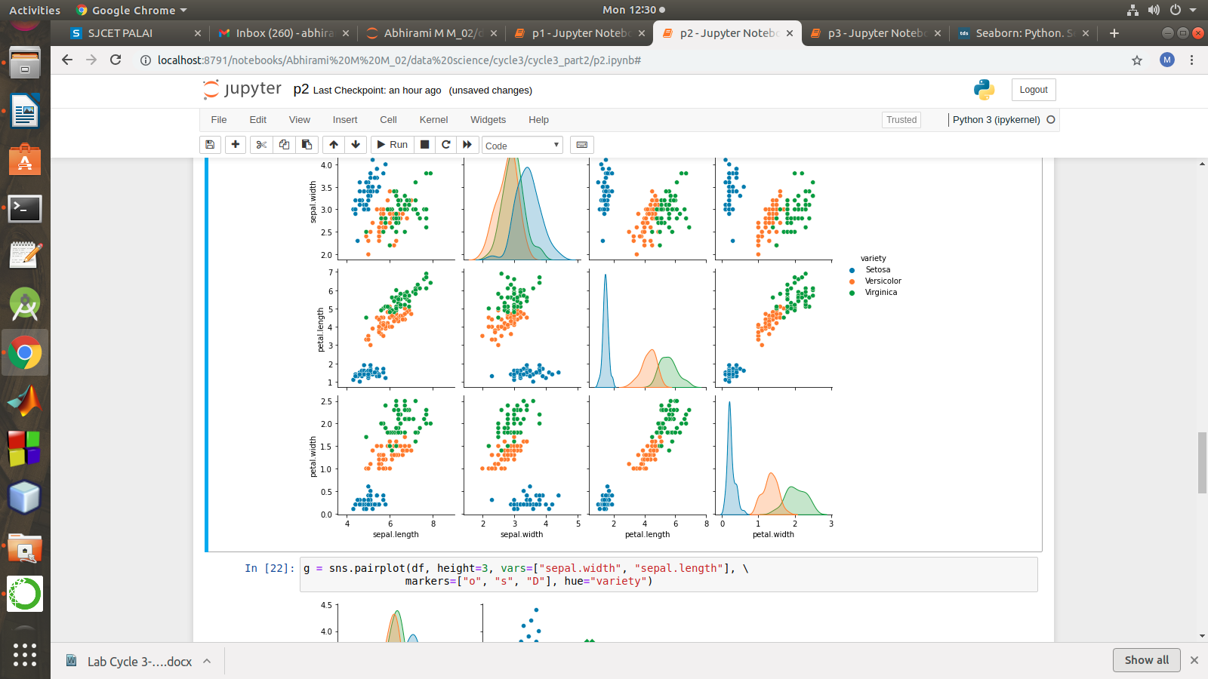

**g = sns.pairplot(df, height=3, vars=["sepal.width", "sepal.length"], \**

**markers=["o", "s", "D"], hue="variety")**

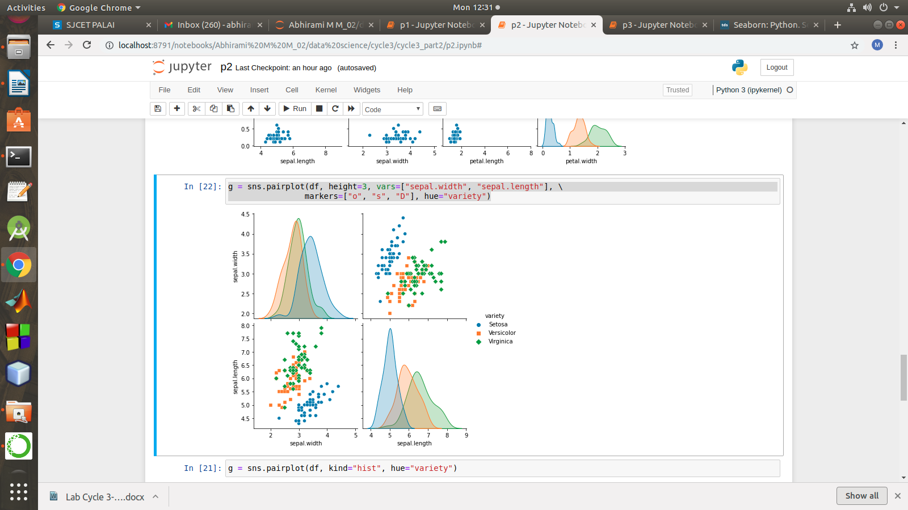

s

**g = sns.pairplot(df, kind="hist", hue="variety")**

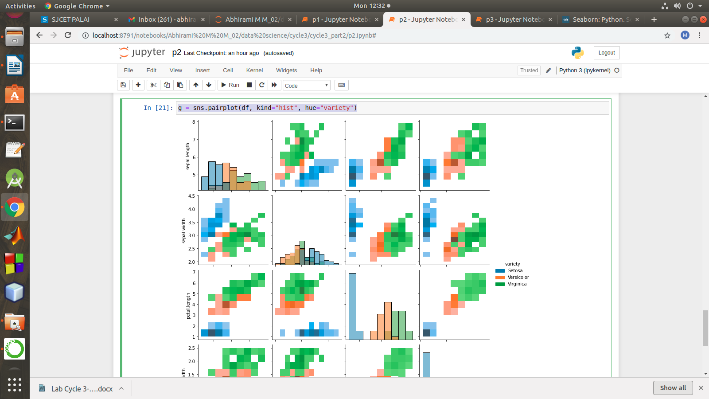

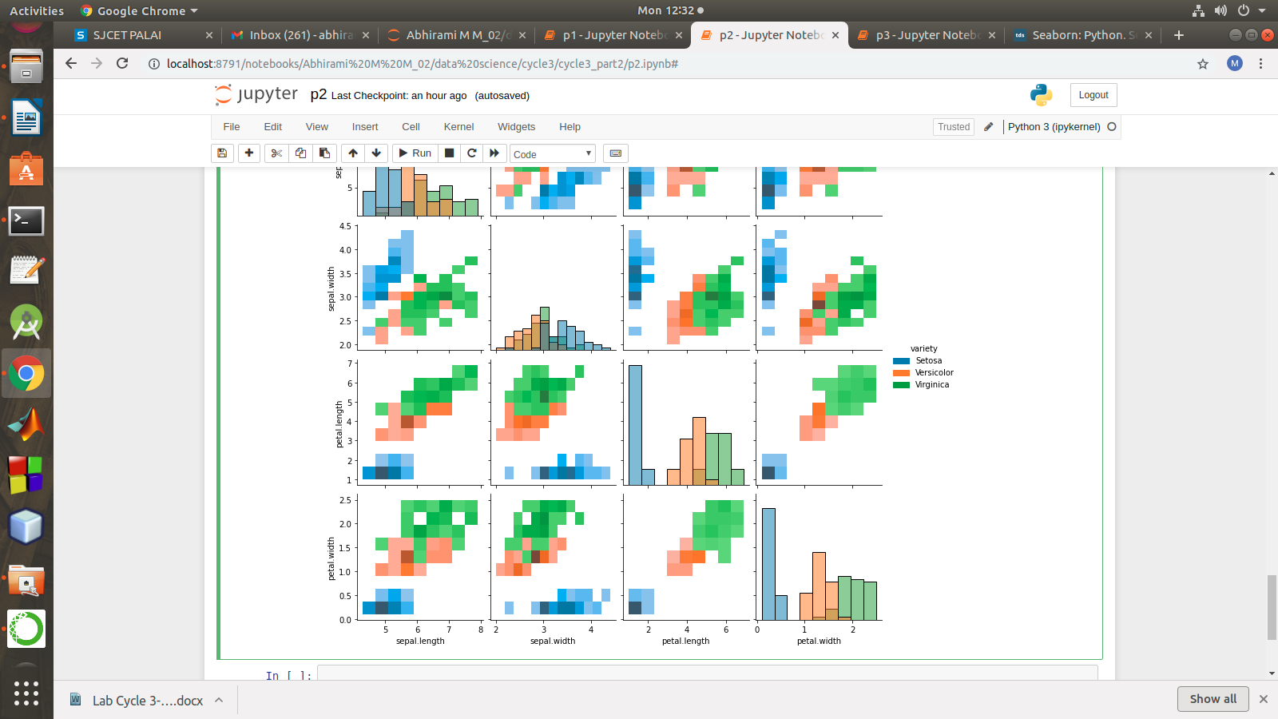

#### using the iris data set,get familiarize with functions:

1)displot()

2) histplot()

3) relplot()

1) import numpy as np

import matplotlib.pyplot as plt

import seaborn as sns

import pandas as pd

col=['sepal_length','sepal_width','petal_length','petal_width','type']

df = sns.load_dataset('iris')

df.head()

sns.displot(x = 'petal_length',kde=True,bins = 5 , data =df)

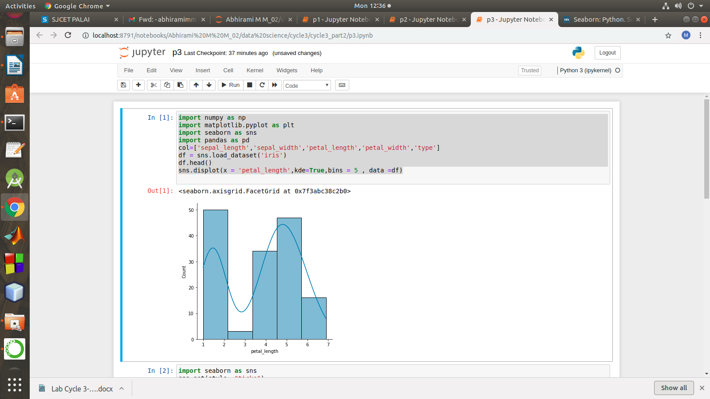

2) import seaborn as sns

sns.set(style ="ticks")

dataset = sns.load_dataset('iris')

col=['sepal_length','sepal_width','petal_length','petal_width','type']

sns.relplot(x ="sepal_length", y ="petal_width", data = dataset)

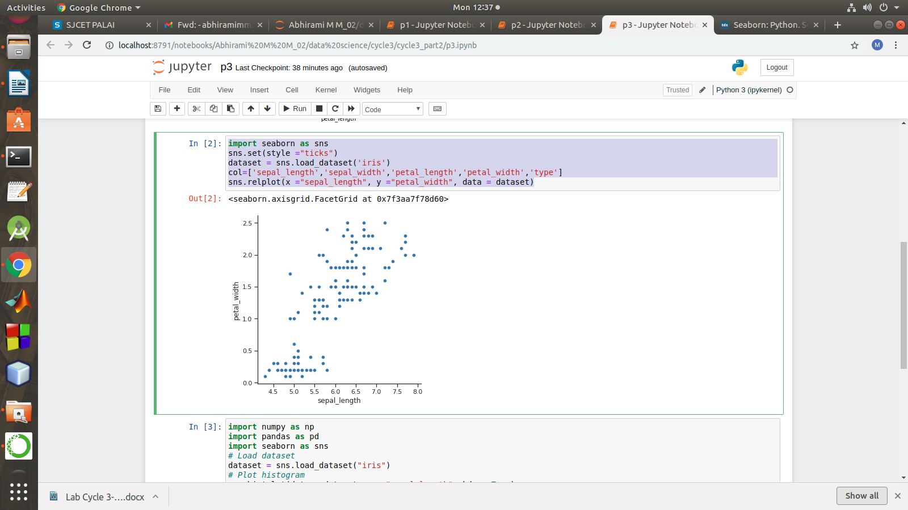

3) import numpy as np

import pandas as pd

import seaborn as sns

# Load dataset

dataset = sns.load_dataset("iris")

# Plot histogram

sns.histplot(data = dataset, x = "sepal_length", kde = True)

